Project 3 - RetrieverBell

**Due Date:** Friday, December 4th, 2020 by 11:59:59 PM

**Value:**  100 points

**This assignment falls under the standard cmsc201 academic integrity policy.  This means you should not discuss/show/copy/distribute your solutions, your code or your main ideas for the solutions to any other student.  Also, you should not post these problems on any forum, internet solutions website, etc.**

Make sure that you have a complete file header comment at the top of each file, and that all of the information is correctly filled out.

**"""**

**File:    FILENAME.py**

**Author:  YOUR NAME**

**Date:    THE DATE**

**Section: YOUR DISCUSSION SECTION NUMBER**

**E-mail:  YOUR_EMAIL@umbc.edu**

**Description:**

**DESCRIPTION OF WHAT THE PROGRAM DOES**

**"""**

Submission Details

Submit the files under the following title:

(These are case sensitive as usual.  )

**If you've done a class based solution:**

submit cmsc201 PROJECT3 network.py switchboard.py phone.py

**If you've done a function based solution with no classes:**

submit cmsc201 PROJECT3 network.py

Project Description

Because of a new surprise round of antitrust cases, a new phone company RetrieverBell was created.  You've been hired as the single programmer whose duty is to code the connection servers for all of the phones signed up with your company.

Like the old days before cell phones, phones will have an area code, which is permitted to be any positive number of digits and a phone number, which is permitted to be any positive number of digits.

In order to connect a phone to another phone, if it's a local number in the same area code, it can connect through its local switchboard.  On the other hand, if it's a long distance number, it has to connect through the connected switchboards.

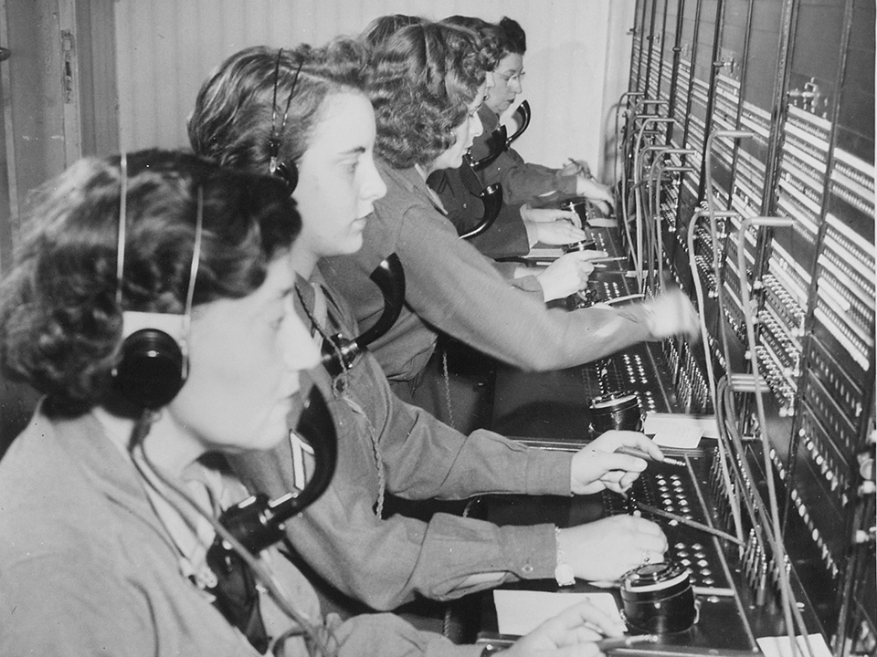

Here's an old switchboard system.

A Sample Diagram of Our Network

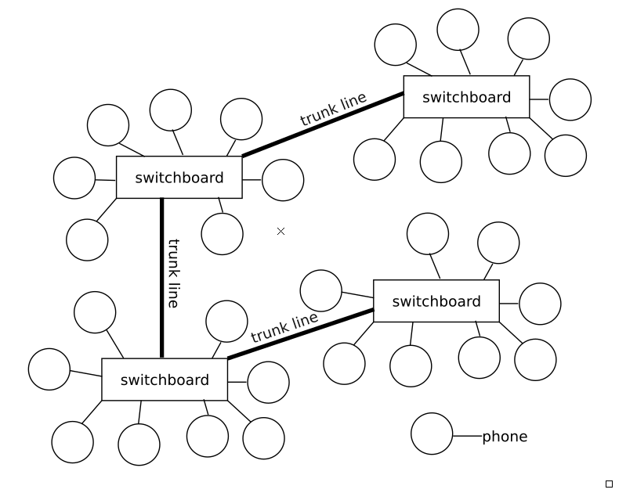

Trunk lines allow us to connect between switchboards and each phone is connected to exactly one switchboard (and has exactly one area code).

In our network, there is a 1-to-1 correspondence between switchboards and area codes.  (I.e. each switchboard has one area code attached, and that area code is fully handled by that board.)

Implementation Details

The required functionality for the project won't be described exactly in the way you have to implement it, but I will specify operations and what they need to do.  This means that if you want to use classes, you can use them, but if you don't, you don't have to.  I've given starter code that assumes that you will use classes.

switch-add

switch-add [area-code-1]

This will create a new switchboard with the area code specified.  The braces are just to indicate that it needs to be replaced with an area code which is a number.  If the switchboard exists, you don't create a new one.

switch-connect

switch-connect [area-code-1] [area-code-2]

This connects the switchboard at [area-code-1] with the one at [area-code-2], and also the reverse connection, which means that they are connected to each other.  Calls can flow in both directions.

phone-add

phone-add [area-code-1]-[num_part_1]-[num_part_2]

phone-add should add a phone number with the area code specified as well as the phone number with one hyphen between the area code and the phone number, but there can be as many hyphens between any other part of the number.  The rest of the number can be combined, or kept as a format with hyphens.

start-call

start-call [phone_number_1] [phone_number_2]

**Connecting a call requires a recursive function.**

start-call should create a connection between the two phone numbers, if the area codes exist, the numbers exist at their proper area codes, and if they are not already in a phone call.  It can only be connected if there is a path along switchboards between the two numbers.  It is possible that no connection will exist because the two switchboards could not be connected by "trunk lines."

end-call

end-call [phone_number_1]

end-call should disconnect the two numbers that are connected.  The disconnection can occur at either end of the call.  If there's no connection from that number, then report that but you don't need to do anything else.

display

display

The display command should output each switchboard with its area-code.  Then output the other area codes/switchboards that it's connected to.  Finally output each local phone number and if it is on the hook, or if it's connected to another phone.  See the sample output for more on how I think it should generally look to make it readable for the console output.

network-save

network-save [filename]

This should save the network in a file.  You can choose the format that you use, and you are permitted to use csv, json packages if you wish.  You must decide on the file format, which must be able to be saved, and then loaded in a different run of the program.  The structure of the network should be saved, but the phone to phone connections can be lost (pretend that all phones are hung up at the start of the load).

network-load

network-load [filename]

This should load the file at file-name.  It should create the network described in the file.  Remember that you have to specify the file format, so you'll need to decide how to save, and how to load.  When you load a network, you should delete the old network or overwrite it, whichever makes sense for your project.

Documentation (Class Based)

Documentation for: class Phone:

This class needs to implement three methods.  You may add more methods as you see fit. 

def __init__(self, number, switchboard):

The constructor should take a number and switchboard and create the Phone instance.  Once done, the phone should be ready to connect to other phones for phone calls.

def connect(self, area_code, other_phone_number):

The connect method should take the destination area code and the destination number and try to connect either locally if the call is local, or through the switchboards to the other area code and finally check to see if there is a phone number that matches the other_phone_number.  If so it should connect, as long as the other phone is not already connected, and as long as the original phone is not connected.

It's possible that there is no path, in that case, don't connect.  It's possible that either phone could already be in a call, so you wouldn't connect then either.  If the other phone's area code or number doesn't exist, you should display that fact too.

def disconnect(self):

The disconnect method should, if the phone in question is connected to another phone, disconnect both of them from the call and return them to their ready state.

Documentation for: class Switchboard:

This class needs to implement four methods.  You may add more methods as you see fit.

def __init__(self, area_code):

The constructor needs to set up the switchboard to have both local phones connected, and connections to other switchboards.

def add_phone(self, phone_number):

This method needs to allow the user to add a phone number to the current switchboard.  You should create a Phone object and add it to your "collection."  Don't create duplicates.

def add_trunk_connection(self, switchboard):

This method adds a connection to another switchboard in the sequence.  Ensure that it's not already connected to the other switchboard and then connect them both to each other (both directions).

def connect_call(self, area_code, number, previous_codes):

**This function must be recursive.**

This method should connect a call with destination area_code, and destination number in that area_code.  previous_codes is probably some collection of previously scanned area-codes, to prevent an infinite recursion.

Documentation for: class Network

This class needs to implement six methods.  You may add more methods as you see fit.

def __init__(self):

The constructor should set up the network to hold the switchboards.

def load_network(self, filename):

This method should load the network from the file (filename).  Remember to reset your network (delete all switchboards/phones) to an empty network before creating a new network.  Do not merge the two networks.

def save_network(self, filename):

This method should save the network to the file (filename).

def add_switchboard(self, area_code):

Adding a switchboard means creating a new Switchboard object with the area_code.  If there's a duplicate, do not allow the creation.

def connect_switchboards(self, area_1, area_2):

This method should connect the switchboards with the two area codes.  If they don't exist, you should print a message.  If they're already connected, display a message indicating that.

def display(self):

The display should print each switchboard, the boards it's connected to, the phone numbers it has locally and whether any of those numbers are in a call.

Provided Files

Class Based Solutions

The three files are provided on the GL server:

/afs/umbc.edu/users/e/r/eric8/pub/cs201/fall20/phone.py

/afs/umbc.edu/users/e/r/eric8/pub/cs201/fall20/switchboard.py

/afs/umbc.edu/users/e/r/eric8/pub/cs201/fall20/network.py

If you choose to use the starter code and implement a class based solution, then remember that the copy command is:

cp [path_to_the_file] [space] [dot]

For instance:

cp /afs/umbc.edu/users/e/r/eric8/pub/cs201/fall20/network.py .

**You will probably have to modify the main driver code to check for safety conditions and display output messages.**

Function Based Solutions (without Classes)

One file is provided on the GL server for this:

/afs/umbc.edu/users/e/r/eric8/pub/cs201/fall20/nonclass_net.py

When you copy this file to your computer, you must rename it network.py. 

**You will probably have to modify the main driver code to check for safety conditions and display output messages.  You are also permitted, encouraged, and probably required to add additional helper functions.**

Sample Output 1

I've provided two sample output runs.  They are far from complete, meaning they don't cover nearly all possible things that can happen.  Your output especially in display doesn't have to match exactly but it should be readably similar.

|  |
| --- |
| **linux3[1729]% python3 network.py**  **Enter command: switch-add 443**  **Enter command: switch-add 410**  **Enter command: switch-add 656**  **Enter command: display**  **Switchboard with area code:  443**  **Trunk lines are:**  **Local phone numbers are:**  **Switchboard with area code:  410**  **Trunk lines are:**  **Local phone numbers are:**  **Switchboard with area code:  656**  **Trunk lines are:**  **Local phone numbers are:**  **Enter command: switch-connect 443 410**  **Enter command: phone-add 656-112-3412**  **Enter command: phone-add 443-132-1332**  **Enter command: display**  **Switchboard with area code:  443**  **Trunk lines are:**  **Trunk line connection to: 410**  **Local phone numbers are:**  **Phone with number: 1321332 is not in use.**  **Switchboard with area code:  410**  **Trunk lines are:**  **Trunk line connection to: 443**  **Local phone numbers are:**  **Switchboard with area code:  656**  **Trunk lines are:**  **Local phone numbers are:**  **Phone with number: 1123412 is not in use.**  **Enter command: start-call 656-112-3412 443-132-1332**  **656-112-3412 and 443-132-1332 were not connected.**  **Enter command: switch-connect 656 410**  **Enter command: start-call 656-112-3412 443-132-1332**  **656-112-3412 and 443-132-1332 are now connected.**  **Enter command: display**  **Switchboard with area code:  443**  **Trunk lines are:**  **Trunk line connection to: 410**  **Local phone numbers are:**  **Phone with number: 1321332 is connected to 656-1123412**  **Switchboard with area code:  410**  **Trunk lines are:**  **Trunk line connection to: 443**  **Trunk line connection to: 656**  **Local phone numbers are:**  **Switchboard with area code:  656**  **Trunk lines are:**  **Trunk line connection to: 410**  **Local phone numbers are:**  **Phone with number: 1123412 is connected to 443-1321332**  **Enter command: network-save sample1.net**  **Network saved to sample1.net.**  **Enter command: quit** |

Sample Output 2

|  |
| --- |
| **linux3[1730]% python3 network.py**  **Enter command: network-load test.net**  **Network loaded from test.net.**  **Enter command: display**  **Switchboard with area code:  310**  **Trunk lines are:**  **Trunk line connection to: 410**  **Local phone numbers are:**  **Phone with number: 2222222 is not in use.**  **Phone with number: 5555555 is not in use.**  **Phone with number: 1111111 is not in use.**  **Phone with number: 1231233 is not in use.**  **Switchboard with area code:  410**  **Trunk lines are:**  **Trunk line connection to: 310**  **Trunk line connection to: 443**  **Local phone numbers are:**  **Phone with number: 2233333 is not in use.**  **Phone with number: 3453456 is not in use.**  **Switchboard with area code:  443**  **Trunk lines are:**  **Trunk line connection to: 410**  **Local phone numbers are:**  **Phone with number: 9109191 is not in use.**  **Switchboard with area code:  545**  **Trunk lines are:**  **Local phone numbers are:**  **Phone with number: 1231234 is not in use.**  **Switchboard with area code:  223**  **Trunk lines are:**  **Local phone numbers are:**  **Phone with number: 1231234 is not in use.**  **Enter command: start-call 223-1231234 410-223-3333**  **223-1231234 and 410-223-3333 were not connected.**  **Enter command: start-call 410-223-3333 310-555-5555**  **410-223-3333 and 310-555-5555 are now connected.**  **Enter command: start-call 310-222-2222 310-111-1111**  **310-222-2222 and 310-111-1111 are now connected.**  **Enter command: display**  **Switchboard with area code:  310**  **Trunk lines are:**  **Trunk line connection to: 410**  **Local phone numbers are:**  **Phone with number: 2222222 is connected to 310-1111111**  **Phone with number: 5555555 is connected to 410-2233333**  **Phone with number: 1111111 is connected to 310-2222222**  **Phone with number: 1231233 is not in use.**  **Switchboard with area code:  410**  **Trunk lines are:**  **Trunk line connection to: 310**  **Trunk line connection to: 443**  **Local phone numbers are:**  **Phone with number: 2233333 is connected to 310-5555555**  **Phone with number: 3453456 is not in use.**  **Switchboard with area code:  443**  **Trunk lines are:**  **Trunk line connection to: 410**  **Local phone numbers are:**  **Phone with number: 9109191 is not in use.**  **Switchboard with area code:  545**  **Trunk lines are:**  **Local phone numbers are:**  **Phone with number: 1231234 is not in use.**  **Switchboard with area code:  223**  **Trunk lines are:**  **Local phone numbers are:**  **Phone with number: 1231234 is not in use.**  **Enter command: end-call 310-111-1111**  **Hanging up...**  **Connection Terminated.**  **Enter command: end-call 545-123-1234**  **Unable to disconnect.**  **Enter command: end-call 410-555-5555**  **Enter command: display**  **Switchboard with area code:  310**  **Trunk lines are:**  **Trunk line connection to: 410**  **Local phone numbers are:**  **Phone with number: 2222222 is not in use.**  **Phone with number: 5555555 is connected to 410-2233333**  **Phone with number: 1111111 is not in use.**  **Phone with number: 1231233 is not in use.**  **Switchboard with area code:  410**  **Trunk lines are:**  **Trunk line connection to: 310**  **Trunk line connection to: 443**  **Local phone numbers are:**  **Phone with number: 2233333 is connected to 310-5555555**  **Phone with number: 3453456 is not in use.**  **Switchboard with area code:  443**  **Trunk lines are:**  **Trunk line connection to: 410**  **Local phone numbers are:**  **Phone with number: 9109191 is not in use.**  **Switchboard with area code:  545**  **Trunk lines are:**  **Local phone numbers are:**  **Phone with number: 1231234 is not in use.**  **Switchboard with area code:  223**  **Trunk lines are:**  **Local phone numbers are:**  **Phone with number: 1231234 is not in use.**  **Enter command: quit** |

Generalized Rubric

I've listed the approximate point values for each part of functionality in the project.  They are subject to change slightly but this will generally be the rubric that we adhere to.  We will break each one of these down into sub-parts which will have point values which add up to close to the approximate point value.

|  |  |
| --- | --- |
| **Functionality** | **Apprx. Point Value** |
| switch-add functionality | 5 |
| display functionality | 5 |
| switch-connect functionality | 10 |
| phone-add functionality | 10 |
| start-call functionality | 25 |
| end-call functionality | 15 |
| network-save/load functionality | 20 |
| Coding Standards | 10 |

Coding Standard: Global Variables

Global variables **are not** permitted for this project beyond a creation of variables in the if __name__ == '__main__': but those variables should be passed into functions or class methods.  They should not be accessed from the global scope.

A global variable is anything declared outside of a class, outside of a method, i.e. not in a class scope or method scope.

Global constants **are permitted** for this project.

This means you can still use global constants at the top of your program, which is recommended.

Coding Standards

Coding standards can be found [here](https://docs.google.com/document/d/1hxv3Lp1TT4xe1HTm3nGBN7EXfq0pMjP40-yfrN4rKRI/edit?usp=sharing).

We will be looking for:

1. At least one inline comment per program explaining something about your code.
2. Constants above your function definitions, outside of the "if __name__ == '__main__':" block.
   1. A magic value is a string which is outside of a print or input statement, but is used to check a variable, so for instance:
      1. print(first_creature_name, 'has died in the fight. ') does not involve magic values.
      2. However, if my_string == 'EXIT':  exit is a magic value since it's being used to compare against variables within your code, so it should be:  
         EXIT_STRING = 'EXIT'

...  
if my_string == EXIT_STRING:

* 1. A number is a magic value when it is not 0, 1, and if it is not 2 being used to test parity (even/odd).
  2. A number is magic if it is a position in an array, like my_array[23], where we know that at the 23rd position, there is some special data.  Instead it should be  
     USERNAME_INDEX = 23

my_array[USERNAME_INDEX]

* 1. Constants in mathematical formulas can either be made into official constants or kept in a formula.

1. Previously checked coding standards involving:
   1. snake_case_variable_names
   2. CAPITAL_SNAKE_CASE_CONSTANT_NAMES
   3. Use of whitespace (2 before and after a function, 1 for readability.)

Allowed Built-ins/Methods/etc

* Declaring and assigning variables, ints, floats, bools, strings, lists, dicts.
* Using +, -, *, /, //, %, **; +=, -=, *=, /=, //=, %=, **= where appropriate
* Comparisons ==, <=, >=, >, <, !=, in
* Logical and, or, not
* if/elif/else, nested if statements
* Casting int(x), str(x), float(x), (technically bool(x))
* For loops, both *for i* and *for each* type.
* While loops
  + sentinel values, boolean flags to terminate while loops
* Lists, list(), indexing, i.e. my_list[i] or my_list[3]
  + 2d-lists if you want them/need them my_2d[i][j]
  + Append, remove
  + **list slicing**
* If you have read this section, then you know the secret word is: enfilade.
* String operations, concatenation +, +=, split(), strip(), join(), upper(), lower(), isupper(), islower()
  + **string slicing**
* Print, with string formatting, with end= or sep=:
  + '{}'.format(var), '%d' % some_int, f-strings
  + Really the point is that we don't care how you format strings in Python
  + Ord, chr, but you won't need them this time.
* Input, again with string formatting in the prompt, casting the returned value.
* **Dictionaries**
  + creation using dict(), or {}, copying using dict(other_dict)
  + .get(value, not_found_value) method
  + accessing, inserting elements, removing elements.
* Using the functions provided to you in the starter code.
* Using import with libraries and specific functions **as allowed** by the project/homework.
* **Recursion - allowed and required for this project.**
* Tuples are allowed, as they are immutable lists.
* json and csv libraries are allowed and optional for project 3.
* File read/write methods:
  + f.read(), f.readlines(), f.readline()
  + f.write(), f.writelines()
  + open(filename, 'r' or 'a', or 'w')
  + with open(filename, mode) as the_file:
  + f.close() if you don't use with.

Forbidden Built-ins/Methods/etc

This is not a complete listing, but it includes:

* break, continue
* methods outside those permitted within allowed types
  + for instance str.endswith
  + list.index, list.count, etc.
* Keywords you definitely don't need: await, as, assert, async, except, finally, global, lambda, nonlocal, raise, try, yield
* The *is* keyword is forbidden, not because it's necessarily bad, but because it doesn't behave as you might expect (it's not the same as ==).
* built in functions: any, all, breakpoint, callable, classmethod, compile, exec, delattr, divmod, enumerate, filter, map, max, min, isinstance, issubclass, iter, locals, oct, next, memoryview, property, repr, reversed, round, set, setattr, sorted, staticmethod, sum, super, type, vars, zip
* If you have read this section, then you know the secret word is: quizzical.
* exit() or quit()
* If something is not on the allowed list, not on this list, then it is probably forbidden.
* The forbidden list can always be overridden by a particular problem, so if a problem allows something on this list, then it is allowed for that problem.